KHALID KHAN

I have tried the same Workspace for Vending Machine on Jupyter Notebook and Anaconda Prompt, This time the python program has been compiled but

TASK 2.

1. I install Python 3.13
2. Install AALpy
3. Install Graphviz
4. Install PyCharm Development Environment

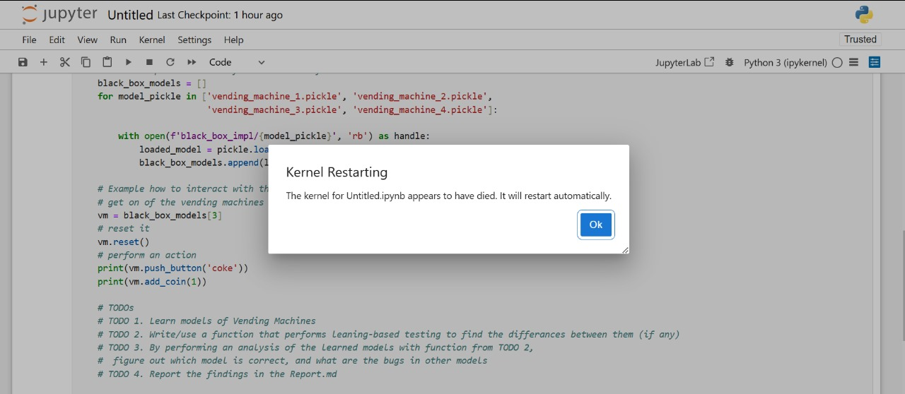

After Installation of all Libraries and Frameworks using Anaconda Prompt and Jupyter Notebook the following error occurs.

The kernel for untitled.ipynb appears to have died. it will restart automatically.